Assignment: Create your own prototypes
Pedro Henrique Nazário da Silva

1 - Submit simple lo-fi prototypes that you can showcase to Ken. Explain how you have addressed the main concerns expressed by Ken in the prototype submitted.

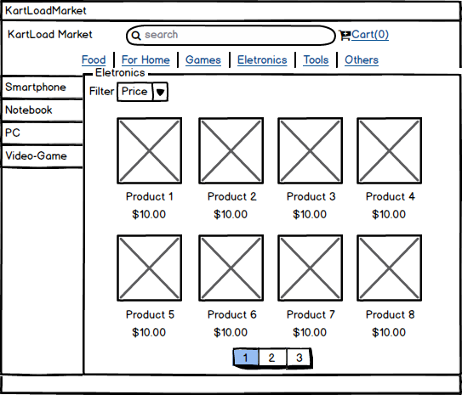

To solve the problem of Ken, I made a main webpage prototype to KartLoad Market. He told that is worried if customers don't get the look of products, so, I created a list of products at main page, that show a list of products from each sub-category. Each product have a category and a sub-category, example: A smartphone is a sub-category from Eletronics.
User can filter these products by price asc & desc or name asc & desc. At top of site, users can search a specific product by name too.

